Experiment No: 5

Experiment Name: Use Google & WHOIS for Reconnaissance

Aim
To perform reconnaissance on an authorized target domain using Google search and WHOIS to collect publicly available information.

Procedure
Step 1: Open a web browser in Kali Linux.
Step 2: Open Google and search for the authorized target website.
Step 3: Collect publicly available information such as:
- Domain name
- Subdomains
- Website pages
- Public contact information
- Other relevant information
Step 4: Open a WHOIS lookup service such as:
Step 5: Enter the authorized target domain, for example:
Step 6: Check the WHOIS information available for the domain.
Step 7: Record details such as:
- Domain registrar
- Domain creation date
- Domain expiry date
- Name servers
- Domain status
Step 8: Compare the information obtained from Google and WHOIS and record the findings.

output

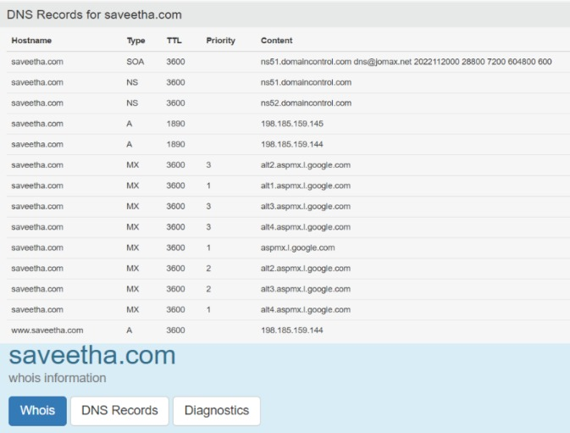
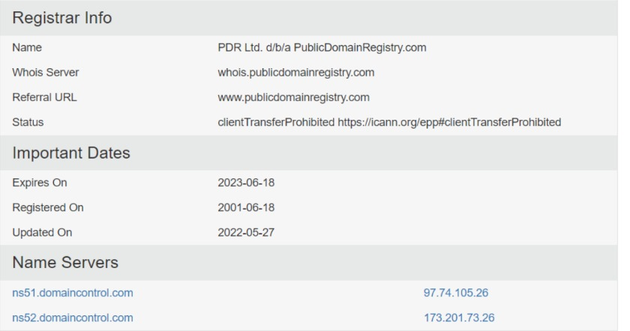

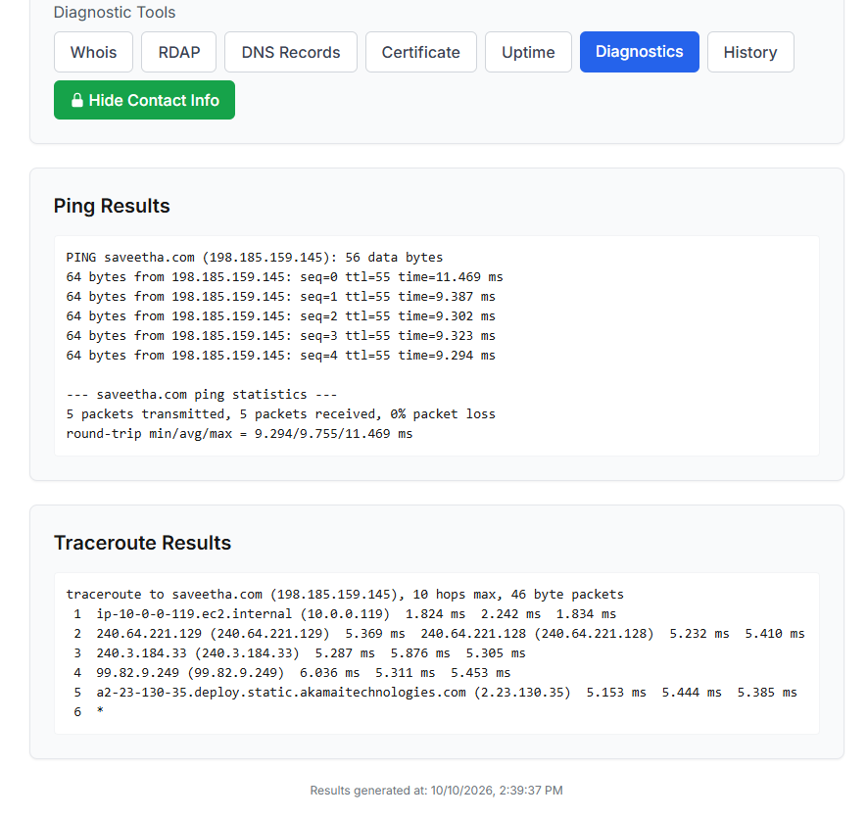

Result
Thus, reconnaissance was successfully performed using Google and WHOIS, and publicly available information about the authorized target domain was collected and analyzed.

